**INNER CASE**

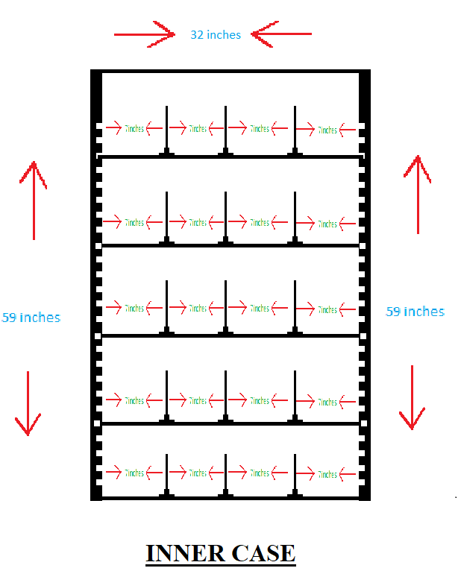

**Description:**

* Bold, Clear and Everlasting FLAT Metallic rack.

**NOTE:** we can adjust the rack position depending on the products as there will be no change in column section.

**Working:**

Many vending machines are equipped with metal spirals to hold products in place. Of course, those spirals are easy to observe if you're peering through a machine with a glass frame.

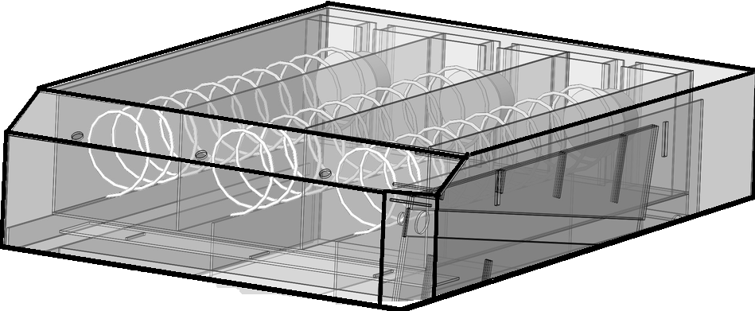

The metal spirals that hold products in place are controlled by a motor, which turns the coils once the processing unit has determined. This allows to deliver your products to drop to the bottom where you can finally pick it.

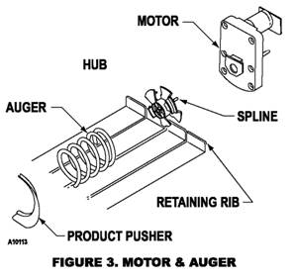

At the bottom of the vending machine, A motion sensor determines if your product has been released by the metal spirals. When your product falls motion sensor detects that there is a product successfully arrived.